**If the lender is TSB Bank PLC:**

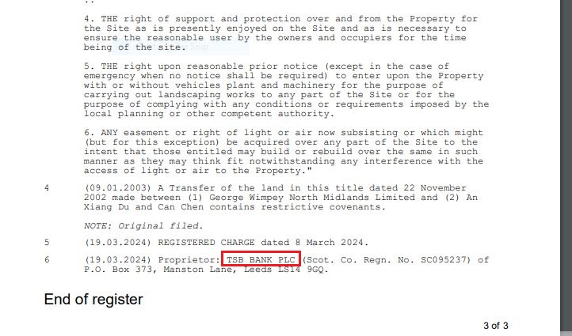

Step 1: Capture the property postcode.

Step 2: Login to LMS STARs

Step 3: Click on “Upload case Document”.

Step 4: Paste the property postcode and then click on “search”.

Step 5: Click on “Select”.



Step 6: Cross check the property address.

Step 7: Select the file type as “Title Information Document”.

Step 8: Select the COMPLETION: 2-reg document then click on “Upload”.

Step 9: Click on “Post Completion”.

Step 10: Click on “Attach Document”.

Step 11: Search “TID to client” click on “Attach Document”.

Step 12: Cross check the name and address of Client then click on “Send”.

Step 13: Click on “Client” in People (there might be multiple clients).

Step 14: Click on “Attach Other Documents”.

Step 15: Search for “COMPLETION:” then tick both the documents.

Step 16: Click on “Mark as Important” type the body and click on “Send”.

Step 17: Click on “Post Completion”.

Step 18: Click on “Mark as Done” for “Completed registration received and checked - names and registered charge correct”.

Step 19: Click on “Mark as Done” for “TID sent to client with any original documents if applicable”.

Step 20: Click on “Mark as Done” for “TID sent to Lender if applicable (update third party platform if applicable - Lender exchange/LMS)”. 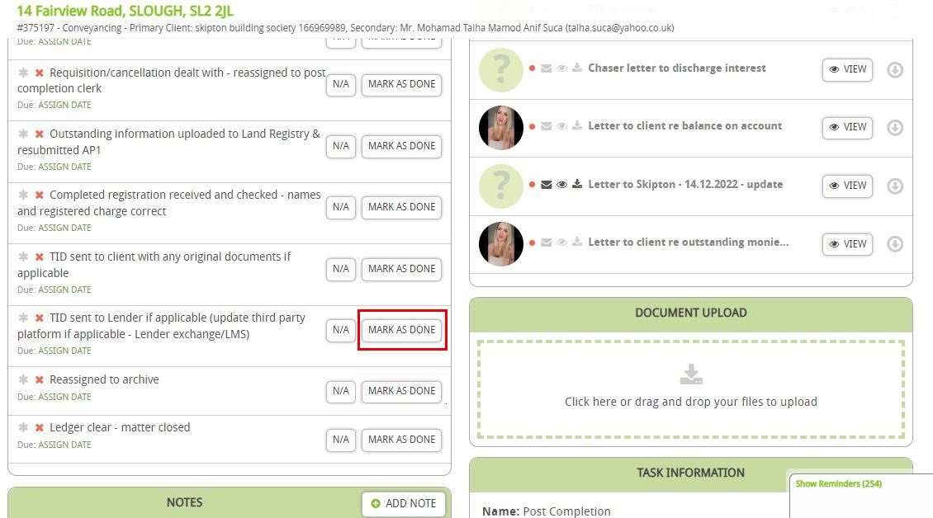

Step 21: Click on “Mark as Done” for “Reassigned to archive”.

Step 22: Click on “Add Note”.

Step 23: Click on “Mark as an Important” type the note on “Content” then click on “Save”.

Step 24: Click on “Mark as Complete”.

Step 25: Click on “OS1 Expiry Date”.

Step 27: Click on “Setting”.

Step 28: Come to case Details Change “Fee Earner for case- Archive” and “Case Worker for case- Archive” then click on “Save”.

**Two COR:**

1. Search “Completion:” and then select the “reg” document. If two “reg” document in the case failed the case and, in the report, it should say “Two reg document found on the case”.

